HEART OF GOLD CHARITY, INC.
1ST Annual Golf Outing Fundraiser

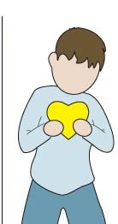

Saturday, August 11, 2007
at
Twin Lakes Country Club
1230 Legion Drive
Twin Lakes, WI 53181

Heart of Gold Charity, Inc.

The mission of this non-profit organization, Heart of Gold Charity, Inc., is to facilitate and provide resources for families dealing with the overwhelming effects of congenital heart defects and to develop medical scholarships. Heart defects account for one percent of all problems that families and their newborns encounter after birth. On August 17, 2006, we were blessed with a beautiful baby boy, Braden Gregory Petska. Just two days later, we learned of Braden’s rare medical condition, Hypoplastic Left Heart Syndrome four life-altering words we will never forget and will battle with for the rest of our lives. Over the next few days, we were introduced to the medical staff that would ultimately give Braden a second chance at life.
Charity efforts of Heart of Gold Charity, Inc. will directly aid families who are currently dealing with a heart defect situation, especially HLHS. Heart of Gold Charity, Inc. will work to provide families with financial relief and supplies during their hospital stay. A prolonged hospital stay with a sick child is one of the most overwhelming experiences anyone can endure. Our first stay at the hospital encompassed roughly forty days and one major open-heart surgery. The hospital truly became our second home. With the money raised, we will provide gift bags that will contain gift cards for restaurants, groceries, and gas. The gift bags will also contain basic toiletries, toys for siblings, and games to pass the time.
Heart of Gold Charity, Inc. will also establish yearly medical scholarships. These scholarships at local high schools will be available for students who are outstanding scholars and citizens interested in pursuing a career in medicine or nursing. Additional money will be used as donations for cardiovascular research at Children’s Hospital of Wisconsin and for treatment centers such as Herma Heart Center at Children’s Hospital of Wisconsin. Yearly donations will also be made to the Ronald McDonald House of Milwaukee.

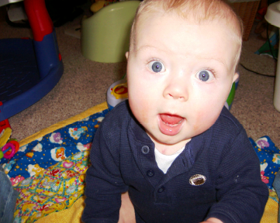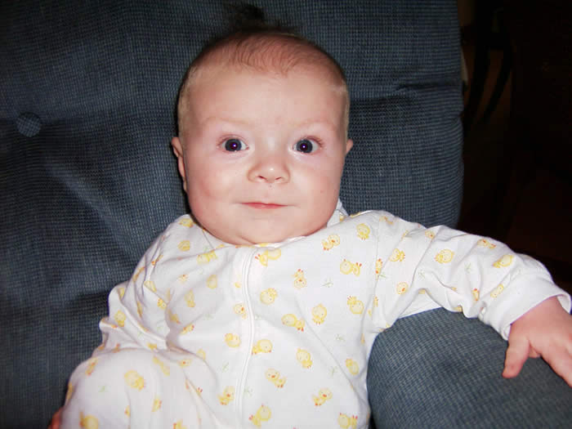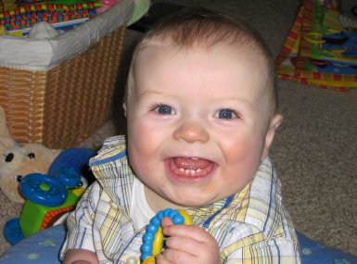
Our family feels it is time to give back and help others through this charity. Today Braden is thriving due to the expertise and care he received from his nurses and doctors. Without these people, their research, and the other HLHS families who came before us, our journey would have been impossible. Our family, friends, and colleagues were also instrumental in the success of our continuing journey. Without their support emotionally, spiritually, and financially, we would not be where we are today. Heart of Gold Charity’s mission is to lend a helping hand to other families whose lives have been touched and forever changed by a congenital heart defect.
Help us help others. Come out and participate in a great day of golf, dinner, and dancing!
Please visit www.heartofgoldcharity.org for more information today!

Heart of Gold Charity, Inc.
1st Annual Golf Outing Fundraiser
Saturday, August 11, 2007

Come out for a great day of golf, silent auction, dinner, dancing and fun at Twin Lakes Country Club to benefit the Heart of Gold Charity’s pursuit to help families fighting heart defects.

Events
Noon Registration for golfers/ 1 PM Shotgun Start
Complimentary beer and brat lunch for golfers
18 holes of Best Ball Format
5:00 PM (Cash bar) open to all guests
6:00 PM Dinner, Awards, Silent Auction
Live Band Entertainment by the Loose Ends

Awards

Closest to the Pin
Longest Drive
Longest Putt
Low Score Winning Foursome
High Score Winning Foursome

Hole-in-One Car Grand Prize

$10,000 towards a New Car Purchase
from Sunnyside Chrysler-Dodge and Richmond Motor Sales

Advertising Sponsorship Opportunity

We are looking for businesses that are interested in sponsoring a hole at our outing. All businesses that become sponsors will be recognized with a sign on a tee box, during our PowerPoint presentation, and during the recognition speech.

Hole Sponsorship: $100

Please fill out the registration form and send your payment to:

Heart of Gold Charity, Inc.
P.O. Box 116
Twin Lakes, WI 53181
Registration and Payment must be received by August 1, 2007

Heart of Gold Charity, Inc.
1st Annual Golf Outing Fundraiser
Saturday, August 11, 2007

Come join us on this very special day at Twin Lakes Country Club for our 1st Annual Golf Outing Fundraiser! By joining in this family-orientated fun day, you will be helping to raise money for families in need, medical scholarships, and research to help fight Congenital Heart Defects. Our son Braden has been the inspiration behind this part of our journey to fight congenital heart defects. Come join us on our journey and be part of a great charity that will make a difference in people’s lives.
The August 11 can’t miss event will be an 18 hole, 4 person team, best ball tournament for golfers of all levels. All golfers will receive an entry prize, lunch, golf and cart, dinner, entertainment, and awards for longest drive, longest putt, closest to the pin, and lowest and highest team score. In addition to those prizes, golfers will win $10,000 towards a purchase of a new car from our great sponsors at Sunnyside Chrysler-Dodge and Richmond Motor Sales by hitting a hole-in-one!

Please fill out the enclosed entry form and mail your payment to reserve your spot today!

Please visit our website at www.heartofgoldcharity.org

If you have any questions, please visit our website or contact us at heartofgoldcharity@yahoo.com

Special thanks to our hardworking Board Members!

Lisa Eisele

Tim Hiller

Lois Petska

Jeff Roach

Marlene Stevens

Andy Youra

Also very special thanks to:

Chad C. and Cliff C. of Twin Lakes Country Club

Chad K. of Avenue A Design at www.avenueadesign.com

Kim Youra Photography

Our Family, Friends, and Co-workers
Heart of Gold Charity, Inc.
1st Annual Golf Outing Fundraiser
Saturday, August 11, 2007

- Space is strictly limited to 144 golfers for our first outing.
- Golfers receive: cart with 18 holes of golf, entry gift, lunch, dinner
- If you don’t have a foursome we will put you in one!
- The Buffet Dinner is limited to 300 total people
- Space is limited and reservations will be made on a first-come, first-served basis for participants that are registered and paid in full.

Golfer #1 or Dinner Guest  Name: ___________________________  Address:__________________________  City: __________________State: _____  Zip: _________Phone:______________  Email: __________________________  T-Shirt Size _________(golfers only) | Golfer #2 or Dinner Guest  Name: ___________________________  Address:__________________________  City: __________________State: _____  Zip: _________Phone:______________  Email: __________________________  T-Shirt Size _________(golfers only)
Golfer #3 or Dinner Guest  Name: ___________________________  Address:__________________________  City: __________________State: _____  Zip: _________Phone:______________  Email: __________________________  T-Shirt Size _________(golfers only) | Golfer #4 or Dinner Guest  Name: ___________________________  Address:__________________________  City: __________________State: _____  Zip: _________Phone:______________  Email: __________________________  T-Shirt Size _________(golfers only)

Hole Sponsors:
Name of Sponsor/Company: __________________________________________
Address: __________________________________________________________
Contact Person/Phone: (____) - _

Payment Information: Complete Payment must be received with registration!
Quantity Total
Number of Golfers @ $85 each (includes lunch and dinner) ______ $______
Dinner Only, No Golf @ $25 each (registration required) ______ $______
Hole Sponsor: $100 ______ $______
Grand Total $______

Send Registration Form and Full Payment to:
Heart of Gold Charity, Inc.
P.O. Box 116
Twin Lakes, WI 53181

Rain Disclaimer- In the event of rain that would cancel the outing, there will be no refunds on any donations made
to the Heart of Gold Charity. However, in the event of rain, dinner will continue as planned.

